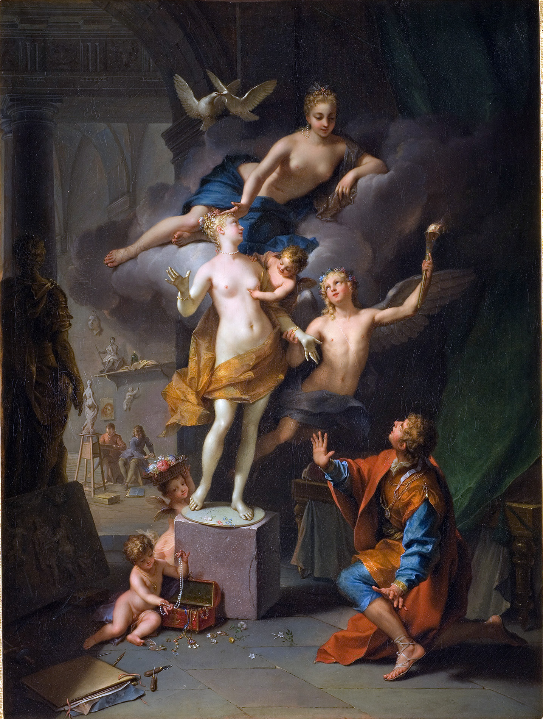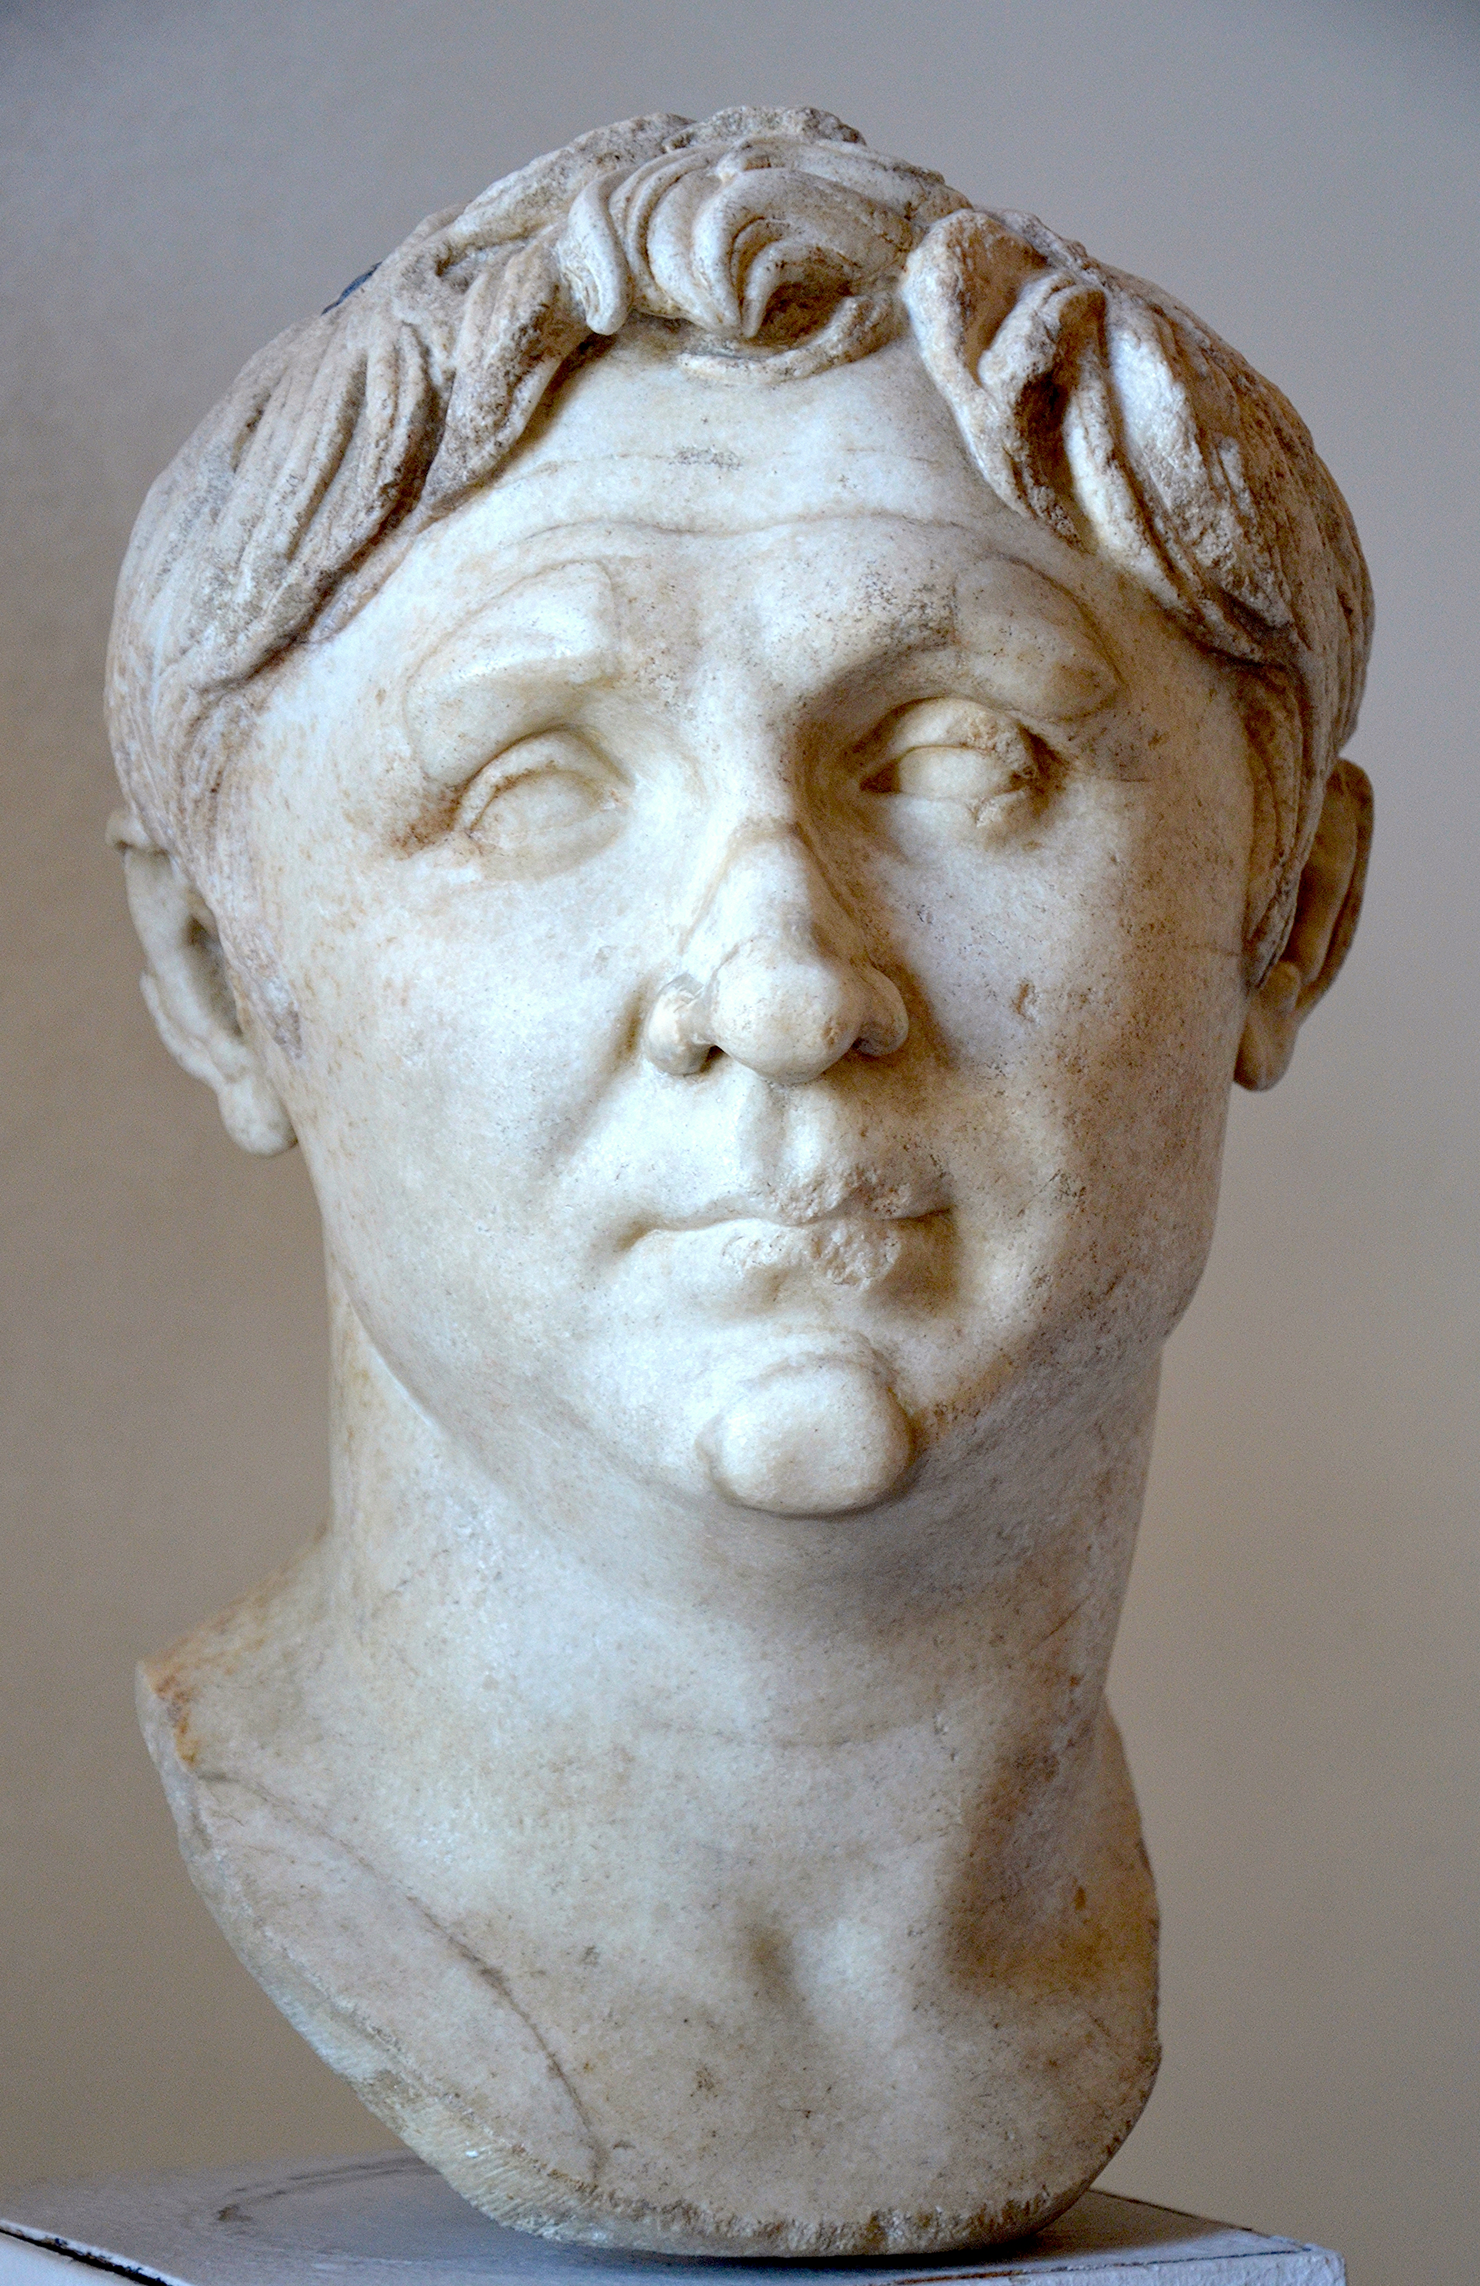
Left: Pygmalion By Jean Raoux - Official gallery link, Public Domain, https://commons.wikimedia.org/w/index.php?curid=4608458
RIGHT: Pompey the Great, Augustan copy of a 70-60 BC original, Venice Museo Archeologico Nazionale, Public Domain—picture By Carole Raddato from FRANKFURT, Germany. https://commons.wikimedia.org/w/index.php?curid=45894958

LATIN 202/344
Roman Epic

Spring 2019
LATN 202 MWF 1:30-2:20 p.m.
LATN 202H/344 MWF 2:30-3:20 p.m.
Professor Erin K. Moodie

Upper intermediate and upper level reading courses designed to consolidate students’ grasp of grammar and syntax, broaden vocabulary, and develop precision and confidence in reading and translation. In spring 2019 we will read portions of ovid’s metamorphoses and (in Latn 344) Lucan’s Civil War.

